Introduction to the World of Computers

Learning Objectives
- Explain why it's essential to learn about computers today.
- Describe several uses for computers in business or personal life.
- Identify some of the major components of a computer system and explain their relationships to one another.

Learning Objectives cont’d.
- Describe the purpose of a network and what the Internet is.
- List the five major categories of computers, giving at least one example of what the computers in each category might be used for.
- Discuss the social impact of computers and some issues that arise from their prominence in our society.

Overview
- This chapter covers the basics of:

  - What computers are and how they work

  - Computer terminology

  - Different sizes of computers

Computers in Your Life
- Most skill-based jobs heavily depend on the creation, collection, and dissemination of information.

- Computers are also prevalent in the home, as well as in our society in general.

- Having experience with, and a basic level of comfort with, computers is important for everyone.

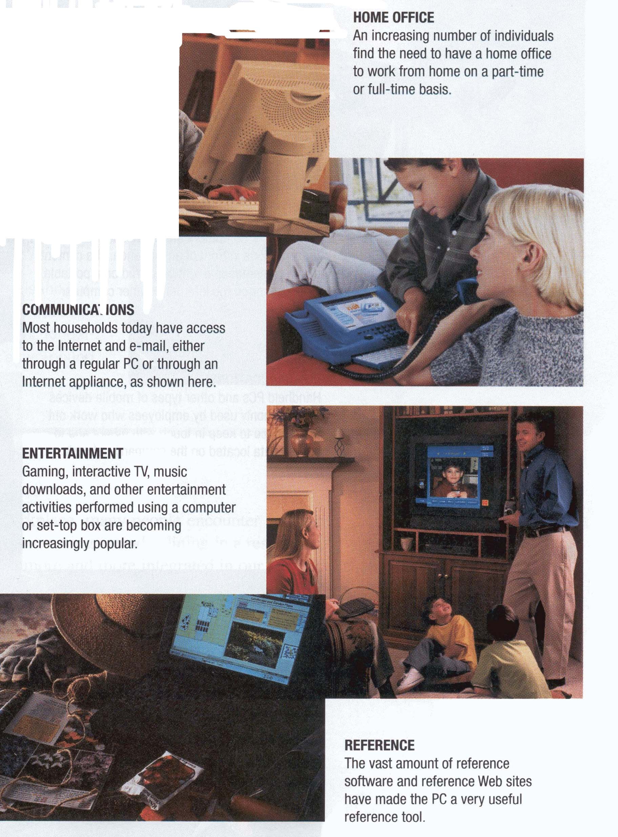
Computers in the Workplace

- Computers in the workplace are used:
  - as multipurpose workstations
  - as presentation tools
  - in networking
  - as design tools

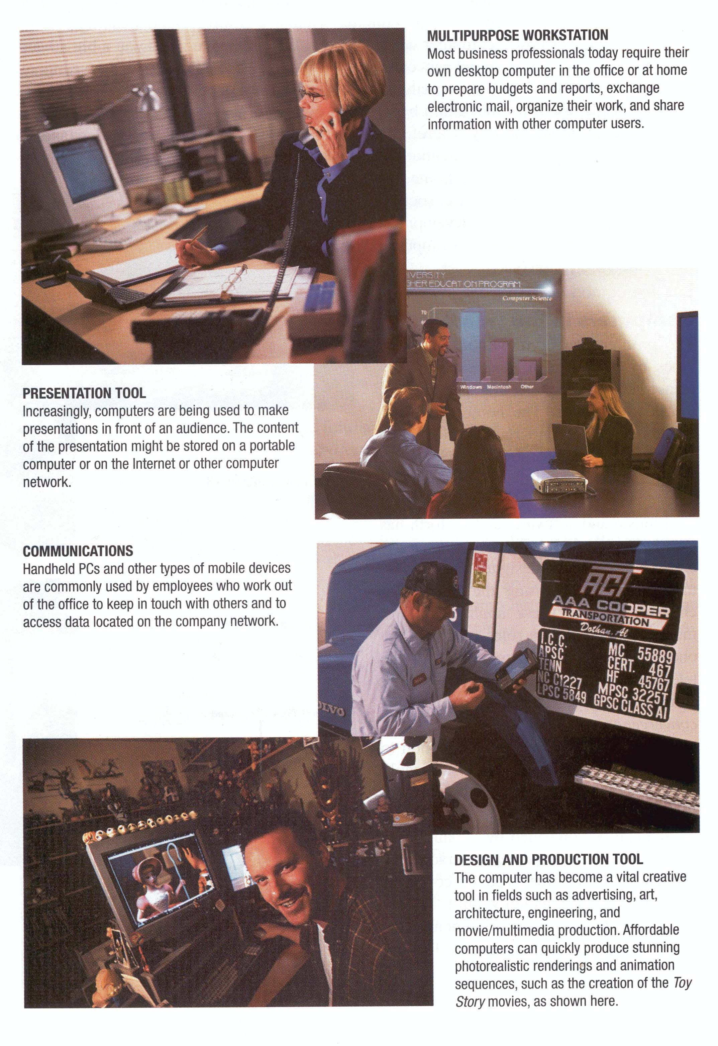

What Is a Computer and What Does It Do?
A computer is a programmable electronic device that accepts input, performs processing on that input, outputs the results, and can store the program, data, or output as needed.
- Input—what is supplied to a computer to process

- Processing—the conversion of input to output

- Output—the results of computer processing

- Storage—saving data, results, or programs for future use
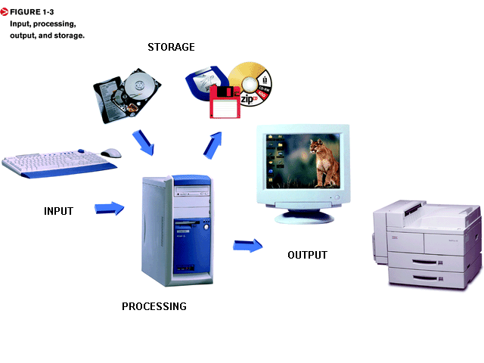 Traditional and Multimedia Hardware
- A computer system consists of the computer itself and its peripheral equipment.

- Multimedia computer systems contain special hardware for use with sound and video.

- The CPU is at the heart of any computer system.

- Volatile memory temporarily stores programs and input while they are being processed.

Hardware
- Hardware refers to the actual machinery that makes up a computer system.

  - Processing device (Central Processing Unit)(CPU)
  - Input devices
  - Output devices
  - Storage devices
Software
- The programs or instructions used to tell the computer hardware what to do.
- Software can be purchased in physical packages or downloaded from the Internet.
- Most software is revised periodically and new versions released.
- Application software performs specific tasks or applications.

- Systems software allows a computer to operate and run application software.

Software refers to computer programs.

System software
      - Operating System
      - Utilities

Applications software
      - Word Processing
      - Spreadsheet
      - Database
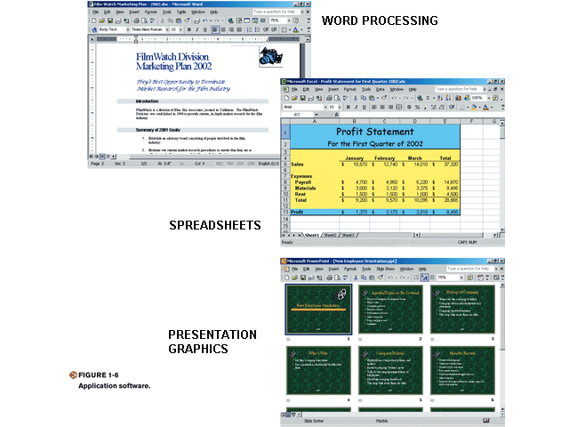

Data, Information, and Programs
- Data = raw, unorganized facts

  - Can be in the form of text, graphics, audio, or video

- Information = data that has been processed into a useful form

- Programs = instructions that tell the computer how to process data to produce the results you want. Programs are written in a programming language, such as Visual Basic, C++, Java, or FORTRAN.

  - Text
  - Graphics
  - Audio
  - Video

- Programs are sets of instructions that tell the computer how to process data to produce information.

- Information are data that have been processed into a meaningful form.

People Make It Happen
- Users, sometimes called end users, are the people who need output from computer systems.
  - Accountants
  - Managers
  - Clerks

- Programmers are the people who write the programs that produce the output for the users, and to supply this information.
  - Applications programmers
  - Systems programmers

Users and Computer Professionals

- Users, or end users, are the people in the computing environment who need the output that computer systems produce.

- Programmers are the people whose job it is to write programs to supply this information.

Computer Networks and the Internet

- A computer network ties users together to share hardware, software, and data, as well as to electronically communicate with each other.
- Computer networks exist in many sizes and types. Many utilize a network server to run the network and host shared programs and data.

The Internet

- The Internet is the largest computer network in the world, connecting millions of PCs and thousands of computer networks together.
- Two of the most common Internet activities are accessing information on the World Wide Web (a huge collection of Web pages) and exchanging e-mail.
- To access a computer network, you need a modem or some other kind of network adapter to physically connect your computer to the network. You also need a software program to let you connect to and use the facilities of a network.

Accessing Networks

- Modem or other network adapter

- Appropriate software program

- ISP

- User ID to log on

- Web browser

Network Servers

- Network servers manage resources on a network.

- Web servers are servers connected to the Internet to store Web pages.

- Online = when a computer can send or receive data from a computer network. Computer users often hear the terms online and offline with reference to computer networks and in various other contexts. Any computer in a state that allows it to send data to or receive data from a computer network or other device is said to be online to the network or device. If a device isn’t online, it’s offline.

Computer Systems to Fit Every Need

- Computers are generally classified in one of four categories: small, or “microcomputers”; medium-sized, or “midrange computers”; large, or “mainframe computers”; and super-large, or “supercomputers.” An emerging new category is “mobile devices,” as discussed next.

- In general, the larger the computer, the greater its processing power. For example, big computers can process data at faster speeds and can perform more complicated types of processing than can small computers. Big computers can also accommodate larger, more powerful support devices.

- Mobile Devices

- Microcomputers

- Midrange computers

- Mainframe computers

- Supercomputers

Mobile Devices

- Very small computing devices
- Based on a wireless phone or pager
- Limited Internet access

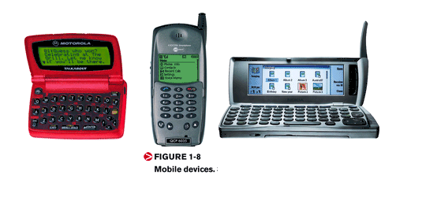
Personal Computers

- A technological breakthrough in the early 1970s made it possible to produce an entire CPU on a single silicon chip smaller than a dime. These “computers-on-a-chip,” or microprocessors, can be mass-produced at a very low cost.

- Microprocessors also made it possible to build inexpensive computer systems small enough to fit on a desk or your lap. The small computers at the heart of these systems have come to be called microcomputers or personal computers (PCs).

- Although most microcomputers designed for home or business use are desktop computers, smaller PCs are available.

- Portable PCs include notebook, tablet, handheld, and pocket computers.

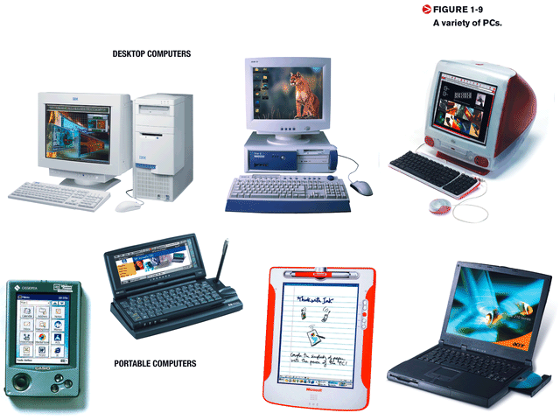
Personal Computers cont’d.
- PCs designed for just network use are referred to as network computers or thin clients.

- PCs or devices designed just for Internet access are called Internet appliances.
Most PC users choose between two major computer platforms when they buy a computer—PC compatibles and Macintosh computers:

- PC compatible—a personal computer based on Intel microcomputer or compatible CPUs. Often, people refer to PC-compatible computers as the Windows platform or as IBM-compatible PCs.

- Macintosh—a type of personal computer manufactured by Apple

Midrange Computers
Midrange computers (or minicomputers) are generally regarded as medium-sized computers. Most of them fall between microcomputers and mainframes in their processing power.
Any of several factors might lead an organization to choose a midrange computer over a PC or
Mainframe. A small or
Medium-sized company,
For example, may find a
Microcomputer system just too
Small or too slow to handle its
Current volume of work.

- Mainstay of almost all large organizations
- Specialize in high-volume processing of business transactions
- Mainframes often operate
24 hours a day, serving
Dozens of users on terminals
During regular business hours
And processing big jobs such
As payroll and billing late
At night.
Supercomputers
- Some organizations, such as large scientific research laboratories, have extraordinary demands for processing power.
- To meet applications needs such as very fast speeds and extreme degrees of accuracy, a few vendors offer very powerful computers, called supercomputers.
- Many supercomputers today are
created by linking together multiple
PCs or microprocessor chips.
Computers and Society

- The information age = the prominence of information technology.

- Benefits of a computer-oriented society include the fact that day-to-day operations of many individuals are positively affected by computers.

- Problems include health and privacy concerns.

